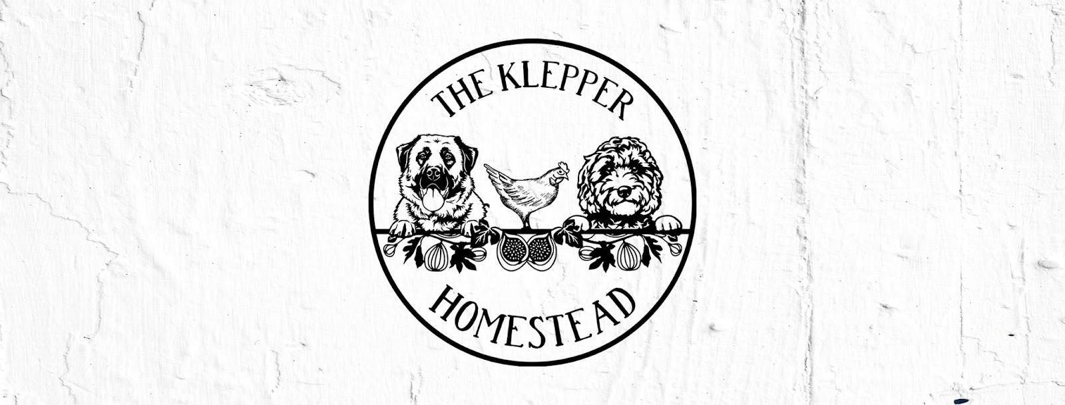

The Klepper Homestead, LLC Stud Contract
Sir Winston Stirling
CGCA CGCU CGC VHMA TKN ATT FDC
Embark Clear
Ee KBky ayat DD bb spsp

Bitch Name & Breed: _____________________________________________________________
Owner(s): ______________________________________________________________________
Address: _______________________________________________________________________
Phone: ________________________________________________________________________
Email: _________________________________________________________________________
AKC or Other Registration: ________________________________________________________
Health Testing Results: ___________________________________________________________

Bitch owner agrees to the following:
- notify stud owner in writing, no later than 70 days after breeding, if only two puppies[viable puppies to live beyond 48 hours] or no pregnancy results from mating. Veterinarian confirmation is required in either case. failure to notify stud owner in either case will result in no return service being provided and full stud fee will be forfeited.
- keep the bitch properly confined until her season is complete.
- agree to not knowingly sell or transfer any puppies resulting from this breeding to any person or firm connected with the business or resale or wholesale of dogs.
- pay any and all vet expenses, including, but not limited to traveling expenses, emergency vet care, etc. related to this breeding.
- to be responsible for all testing done to the bitch prior to and during breeding to ensure proper timing of said breeding. If bitch cannot be bred naturally, the bitch owner is responsible for AI costs.
- If bitch owner is not willing to pay for progesterone testing, smears, or other testing we will try our best to breed the dogs at the proper time but if no puppies result the deposit is forfeited and no repeat breeding is offered.
- that no puppies resulting from this breeding may be sold to brokers, pet shops, or puppy mills.

Stud fee balance of 1500 is due at drop off of bitch. Bitch may be boarded up to 5 days or 2-3 ties around 24-48 hours apart at stud owners home.

By this contract it is specifically agreed that the stud owner is not obligated to sign the application for litter registration until, and unless, the stud fee and any other related financial arrangements have been paid in full. I understand the above written contract and agree to abide by all sections, both typed and written. Should either party seek legal action for violations of this agreement, the bitch owner will assume any and all attorney costs and court fees. In addition, any litigation will take place in Charlotte, NC. This agreement is made between

Stud Owner: _________________________________________________________________________
Bitch Owner: _________________________________________________________________________

